KNOWLEDGE BASED SYSTEMS
1.1. Introduction
1.1.1. AI Concepts
      - Intelligence and types of intelligence
      - Understanding AI
      - History of AI
      - Characteristics of AI
      - Modeling and AI System
      - Main branches of AI
      - Applications of AI:
          - Application areas
          - Application domains
• Problem solving techniques
1.2. Intelligence
1.2.1. Dictionary definition
      - The ability to learn or understand or to deal with new situations
      - The ability to apply knowledge to manipulate one’s environment or to think abstractly as measured by objective criteria (as tests)
1.2.2. Types of Intelligence
According to Howard Gardner’s multiple intelligence theory, there are various types of intelligence viz:
      - General intelligence: - Abilities that allow us to be flexible and adaptive thinkers, not necessarily tied to acquired knowledge.
      - Linguistic-verbal intelligence: - Use words and language in various forms /
Ability to manipulate language to express oneself poetically
      - Logical-Mathematical intelligence: - Ability to detect patterns / Approach problems logically / Reason deductively
      - Musical intelligence: - Recognize nonverbal sounds: pitch, rhythm, and tonal patterns
      - Spatial intelligence: - Typically thinks in images and pictures / Used in both arts and sciences
      - Intrapersonal intelligence: - Ability to understand oneself, including feelings and motivations / Can discipline themselves to accomplish a wide variety of tasks
      - Interpersonal intelligence: - Ability to "read people"—discriminate among other individuals especially their moods, intentions, motivations; / Adept at group work, typically assume a leadership role.
      - Naturalist intelligence: - Ability to recognize and classify living things like plants, animals
      - Bodily-Kinesthetic intelligence: - Use one’s mental abilities to coordinate one’s own bodily movements
Note: Understanding the various types of intelligence provides theoretical foundations for recognizing different talents and abilities in people
1.3. What is AI?
There is no agreed definition of the term artificial intelligence. However, there are various definitions that have been proposed. These are considered below.
      - AI is a study in which computer systems are made that think like human beings. Haugeland, 1985 & Bellman, 1978.
      - AI is a study in which computer systems are made that act like people. AI is the art of creating computers that perform functions that require intelligence when performed by people. Kurzweil, 1990.
      - AI is the study of how to make computers do things, which at the moment people are better at. Rich & Knight .AI is the study of computations that make it possible to perceive, reason and act. Winston, 1992
      - AI is considered to be a study that seeks to explain and emulate intelligent behaviour in terms of computational processes. Schalkeoff, 1990.
      - AI is considered to be a branch of computer science that is concerned with the automation of intelligent behavior. Luger & Stubblefield, 1993.
Artificial Intelligence is the development of systems that exhibit the characteristics we associate with intelligence in human behavior:
      - perception,
      - natural language processing,
      - reasoning, planning,
      - problem solving,
      - learning and adaptation, etc.
Development of AI: History
1943 McCulloch & Pitts: Boolean circuit model of brain
1950 Turing’s “Computing Machinery and Intelligence”
1950s Early AI programs, including Samuel’s checkers (draughts) program Newell
& Simon’s Logic Theorist, Gelernter’s Geometry Engine
1956 Dartmouth meeting: “Artificial Intelligence” adopted
1966–74 AI discovers computational complexity, Neural network research almost disappears
1969–79 Early development of knowledge-based systems
1980–88 Expert systems industry booms
1988–93 Expert systems industry busts: “AI Winter”
1985–95 Neural networks return to popularity(Return of ANN)
1988– Resurgence of probabilistic and decision-theoretic methods Rapid increase in technical depth of mainstream AI, “Nouvelle AI”: ALife, GAs, soft computing Turing Test for Intelligence Tests the ability of a computer system to act humanly
The aim is to determine if the human interrogator thinks he/she is communicating with a human.
To pass Turing Test the computer must:
- Process natural language;
- Represent knowledge;
- Reason;
- Learn and adapt to the new situations.
Total Turing test included vision & robotics.
Characteristics of AI
- Symbolic Processing: AI emphasizes manipulation of symbols rather than numbers. The manner in which symbols are processed is non-algorithmic since most human reasoning process do not necessarily follow a step by step approach (algorithmic approach).
- Heuristics: Are similar to rules of thumb where you need not rethink completely what to do every time a similar problem is encountered.
- Inferencing: This is a form of reasoning with facts and rules using heuristics or some search strategies.
- Pattern matching A process of describing objects, events or processes in terms of their qualitative features and logical and computational relationships.
- Knowledge Processing Knowledge consists of facts, concepts, theories, heuristics methods, procedures and relationships.
- Knowledge bases. Collection of knowledge related to a problem or an opportunity used in problem. Reasoning occurs based on this knowledge base.
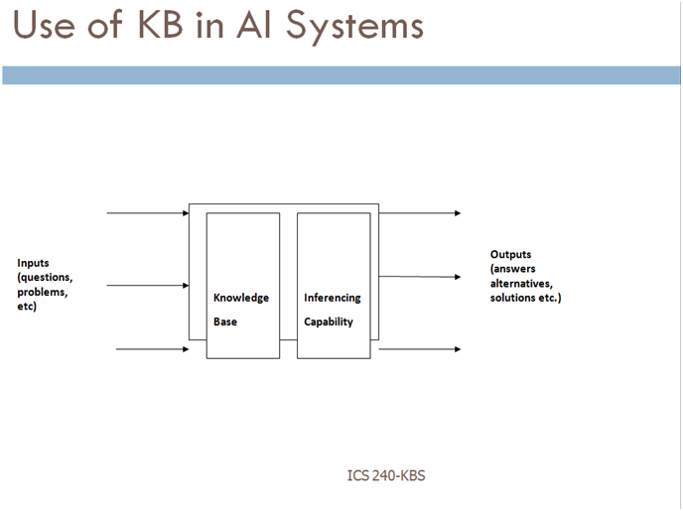
Contrasting AI with Natural Intelligence
Important commercial advantages of AI are:-
- AI is permanent as long as computer system and programs remain unchanged
- AI offers ease of duplications and dissemination as compared to long apprenticeship for natural intelligence.
- AI can be less expensive than natural intelligence.
- AI being a computer system is consistent and thorough; natural intelligence may be erratic since people are erratic, they don’t perform consistently.
- AI can execute certain tasks much faster than humans can.
- AI can perform certain tasks better than many or even most people.
Natural Intelligence has the following advantages
- Natural intelligence is creative, AI is uninspired- human always determine knowledge.
- Natural intelligence enables people to benefit from use of sensory experience directly, while most AI systems must work with symbolic knowledge.
Modelling an AI System A typical AI system consists of three subsystems, i.e.,
- Perception Subsystem
- Reasoning Subsystem
- Action Subsystem(made of actuators/effectors)
Main Branches of AI AI research and application can be categorized into field’s along different dimensions.
- By the scope of cognitive/Intelligent capacities under research - the fields include: Core cognitive facilities e.g. searching, reasoning, learning, planning categorizing and recognizing. Input/output facilities e.g. sensors.
- By the type of major techniques - the fields include: Rule – Based system Case based system Neural networks Genetic programming Logical programming (e.g. Prolog) Functional programming(e.g. lisp)
- By the domains of application - the fields include: game playing theorem proving data mining etc
- By the design Symbolic AI – Designers explicitly program all of the AI “knowledge.” Connectionist AI – Designers “teach” an artificial neural network what the AI needs to “know.” Evolutionary AI – Designers give the AI the ability to refine itself
AI application areas
- Game Playing
  - Much of the early research in state space search was done using common board games such as checkers, chess, and the 15-puzzle
  - Games can generate extremely large search spaces. These are large and complex enough to require powerful techniques for determining what alternative to explore
- Automated reasoning and Theorem Proving
  - Theorem-proving is one of the most fruitful branches of the field
  - Theorem-proving research was responsible in formalizing search algorithms and developing formal representation languages such as predicate calculus and the logic programming language
- Expert System
- One major insight gained from early work in problem solving was the importance of domain-specific knowledge
- Expert knowledge is a combination of a theoretical understanding of the problem and a collection of heuristic problem-solving rules
- Current deficiencies:
  - Lack of flexibility; if human cannot answer a question immediately, he can return to an examination of first principle and come up with something
  - Inability to provide deep explanations
  - Little learning from experience
- Natural Language Understanding and Semantics
  - One of the long-standing goals of AI is the creation of programming that are capable of understanding and generating human language
- Modeling Human Performance
  - Capture the human mind (knowledge representation)
- Robotics
  - A robot that blindly performs a sequence of actions without responding to changes or being able to detect and correct errors could hardly be considered intelligent
  - It should have some degree of sensors and algorithms to guide it
- Machine Learning
  - Learning has remained a challenging area in AI
  - An expert system may perform extensive and costly computation to solve a problem; unlike human, it usually doesn’t remember the solution
  - Examples include:
    - Decision tree learning
    - Genetic algorithms
    - Neural networks
Application Domains of AI
  - Application domain areas include:
  - Military
  - Medicine
  - Industry
  - Entertainment
  - Education
  - Business
Problem Solving Techniques in AI Problems are tackled in AI using two main approaches namely:
- Search technique
- Modelling natural phenomena (e.g. evolution and neural networks).
Ontology
Ontology encompasses a representation, formal naming and definition of the categories, properties and relations between the concepts, data and entities that substantiate one, many, or all domains of discourse

Revision Questions
Example . What is Artificial Intelligence?
- Describe the Turing Test. .
Solution:
Artificial intelligence is a study in which computer systems are made that act like people. People in this group include Kurzweil, 1990 who particularly thought that AI is the art of creating computers that perform functions that require intelligence when performed by people. Rich & Knight were also in this group and they considered AI as the study of how to make computers do things which at the moment people are better at.
the turing test is whereby The human interrogator thinks he/she is communicating with a human.
To pass Turing Test the computer must:
Process natural language;
Represent knowledge;
Reason;
Learn and adapt to the new situations.
EXERCISE 1. What is intelligence? and Can intelligence be mechanized?
References and Additional Reading Materials
- A. Barr, E. A. Feigenbaum, and P. R. Cohen. The Handbook of Artificial
Intelligence. William Kaufman. Los Altos, CA. 1981 (3 vols.)
- B. G. Buchanan and R. O. Duda. Principles of Rule-Based Expert Systems. Report STAN-CS-82-926. Stanford University, August, 1982.
- F. Hayes-Roth, D. A. Waterman, and D. B. Lenat, (Eds.). Building Expert Systems. Addison-Wesley, Reading, MA.. 1983.
- E. Rich. Artificial Intelligence. McGraw-Hill, New York, NY, 1983.

